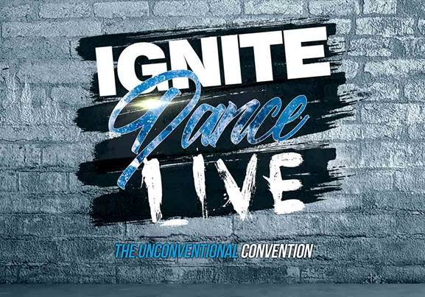

Ignite Dance Live
Classes at Starbound Nationals

MINI’S & JUNIORS-Morning Session

- 8:30-9:00AM: Registration
- 9:00-10:00AM: Contemporary/Lyrical
- 10:00-11:30AM: Music “Live”: Commercial/Musical Theater
- 11:30AM-12:30PM: Hip-Hop/Jazz Funk
- 12:30-1:00PM: Improv/Technique
- 1:00PM: End of Session One

TEENS & SENIORS-Afternoon Session

- 12:30-1:00PM: Registration
- 1:00-2:00PM: Contemporary/Lyrical
- 2:00-3:30PM: Music “Live”: Commercial/Musical Theater
- 3:30-4:30PM: Hip-Hop/Jazz Funk
- 4:30-5:00PM: Improv/Technique
- 5:00PM: End of Session Two

Thank you for attending! Find Your Fire!

